Câu 2:

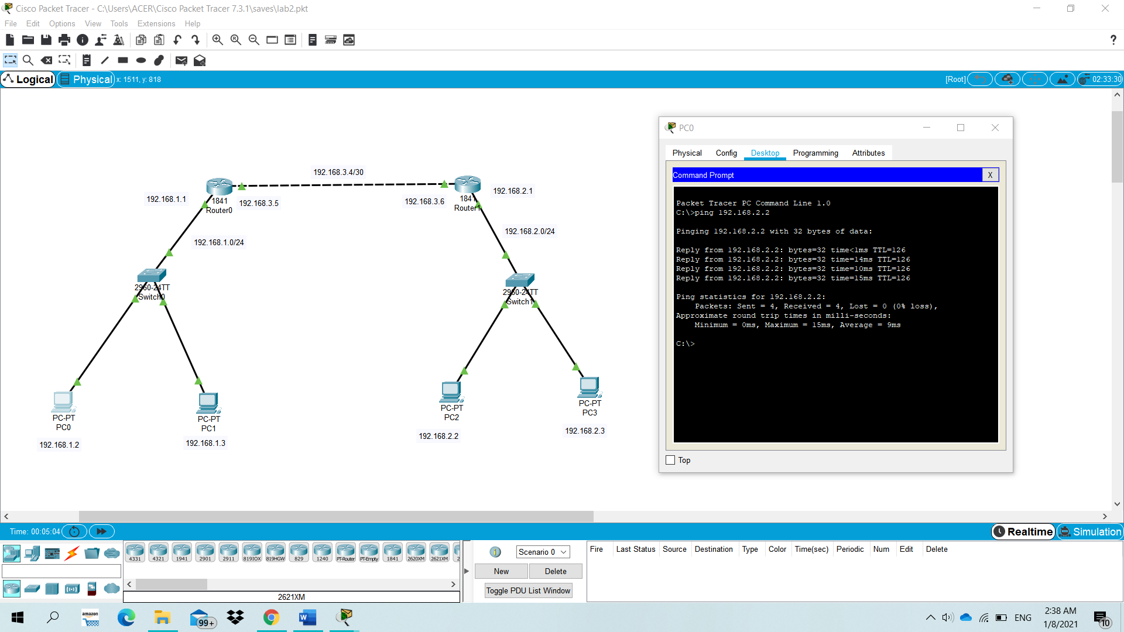

Ping from PC0 to PC2

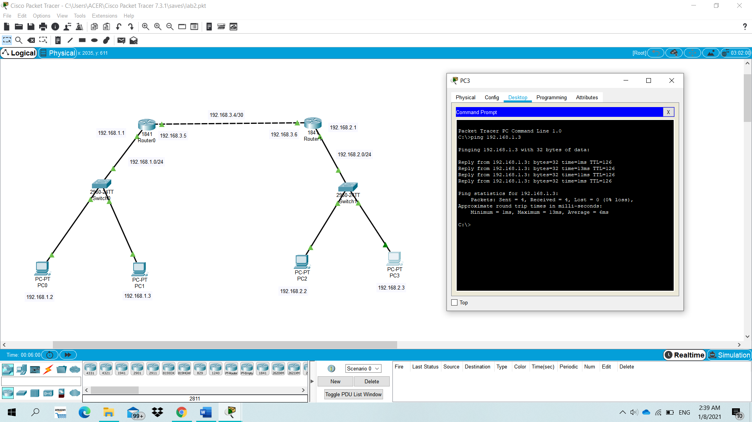

Ping from PC3 to PC1

2.

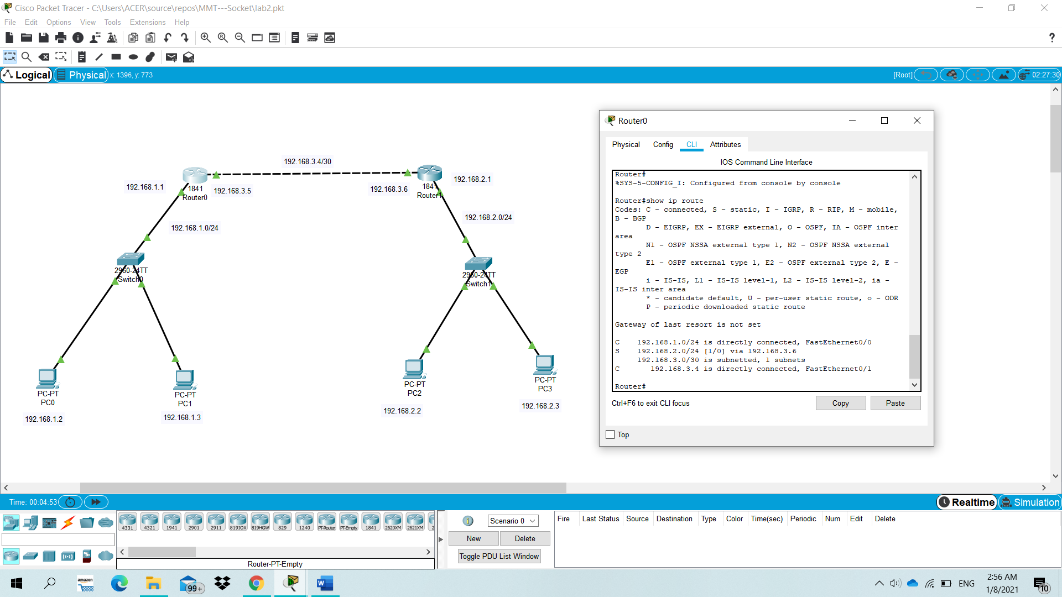

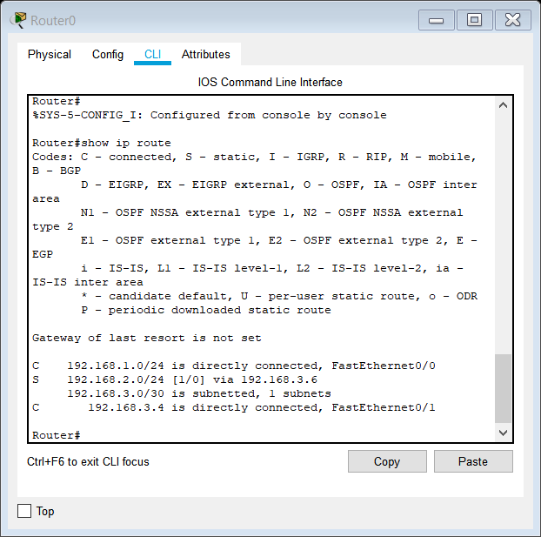

3.

Line is configured by static route in R0:

* The number in red square is the administrative distance (“1” means static route), the number in the blue square is the metric of static route (“0” is the cost of a route).

